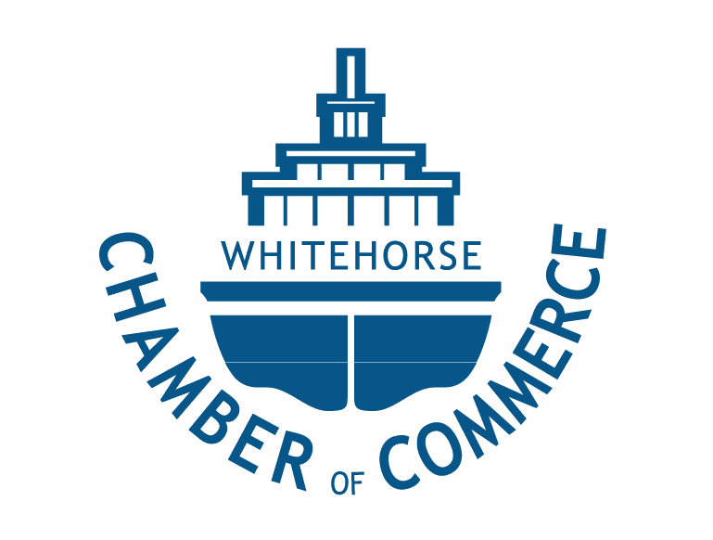

Financial, Tax and Accounting Considerations of Starting a New Business Workshop
Presented by the Whitehorse Chamber of Commerce

Facilitated by: Partners and staff of Crowe Mackay LLP, Whitehorse. All presenters will be Chartered Professional Accountants.
Date: 4 classes - February 4th, 11th, 18th, 25th (Tuesdays)
Time: 8:30am – 10:00am (with additional time for questions as required)
Location: Crowe MacKay offices – Suite 200-303 Strickland St, Whitehorse

COURSE OUTLINE:

Canada is one of the easiest countries in the world to get a business started (and there are things to consider when doing so) and in the early months and years of establishing a business we tend to get involved in building the business and establishing our niche in the marketplace. What we sometimes forget about, or give to others to look after, are the administrative details. Understanding these details is required not only to meet tax responsibilities (corporate, GST and payroll), but also to assist in making the business sustainable and profitable.

This workshop is well suited to individuals thinking about starting a business, individuals who are commercializing their ideas as well as for those who have operating a business for a few years and are looking to better understand or improve the “back office” functions. A reference binder will be provided.

CLASS 1
Establishing A Business

- Introduction of presenters.
- Summary of course material – what will be discussed and what won’t be. General “style” of the course – questions and open dialogue encouraged.
- Components of a business plan
- Start of a business – i.e. when are you “in business”?
- Considering the various expenses (fixed and variable) for a business
- Proprietorship vs. corporation – pros and cons (and costs) of each
- Process of incorporating a business
- Process of registering with tax authorities and other authorities (e.g. CRA Business Number, GST, WCB, City of Whitehorse or Government of Yukon for business license)
- Name searches
- Other business arrangements – partnerships, joint ventures

CLASS 2
Maintaining Your Financial Records
- Bookkeeping and record keeping, in house vs. outside professional bookkeeping, choosing a bookkeeper, methods of maintaining complete and accurate records
- Cash vs. accrual accounting
- Presentation of popular accounting software packages (Quickbooks,Sage)
- Basic internal control concepts
- Setting up a chart of accounts
- Invoicing – what needs to be on the invoice/receipt?
- Establishing bank accounts; getting a business credit card
- Home office expenses – what are the rules and how to track these costs
- Year-end accounting (required to prepare financial statements and tax return)

CLASS 3
Taxation Of Your Business
- Identifying the various taxes (e.g. corporate taxes, GST, payroll taxes) and filing requirements and processes for each type
- Selecting a year-end for a corporation
- Vehicles: personal vs. corporate owned, how to track usage
- Tax planning (e.g. how to pay owner of a corporation through wages or dividends)
- Drawing funds from a corporation through loans to the shareholders
- Personal vs. business expenses – what can be legitimately claimed as a deduction
- Employee vs. subcontractor: the tax implications of each and the risks if not classified correctly
- Tax effect of home office expenses

CLASS 4
Cash And Other Important Matters
- Cash Planning and Forecasting: short-term and long-term, budgeting processes
- Cash on hand vs. cash available for use (e.g. not using GST collected or payroll remittances as cash available)
- Accepting payments (cash, credit card, online) – how does each work and what are the fees?
- Credit – extending credit to customers, how to track it and how to collect
- Planning for capital assets – cash management and accounting
- Obtaining credit and financing your own business (debt, equity); options available in marketplace
- Insurance – property, business interruption, employee fidelity, directors liability
- Professional advisors and government assistance
- General discussion on specific sectors (e.g. internet based businesses)
- Implications of operating in multiple jurisdictions
- Buying an existing business or franchise
Binders of reference material will be provided.

